Topic- A Privacy-Preserving Federated XGBoost Model for Proactive Patient Readmission Management

1.System Architecture & Methodology (Very Important)
Figure 1: Overall System Architecture Diagram
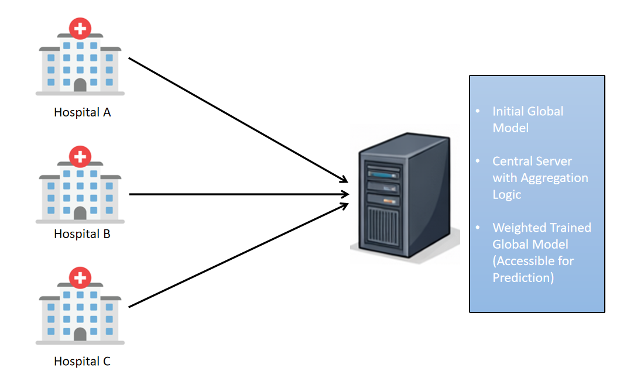

- Dataset & Data Understanding
Table 1: Dataset Description
Feature Category | Description
Total Patients | 101766
Number of Features | 50
Numerical Features Use | 'time_in_hospital','num_lab_procedures', 'num_procedures','num_medications', 'number_outpatient','number_emergency', 'number_inpatient', 'number_diagnoses'
Categorical Features Use | 'race', 'gender', 'age', 'weight', 'diag_1', 'diag_2', 'diag_3', 'max_glu_serum', 'A1Cresult', 'metformin', 'repaglinide', 'nateglinide', 'chlorpropamide', 'glimepiride', 'acetohexamide', 'glipizide', 'glyburide', 'tolbutamide', 'pioglitazone', 'rosiglitazone', 'acarbose', 'miglitol', 'troglitazone', 'tolazamide', 'examide', 'citoglipton', 'insulin', 'glyburide-metformin', 'glipizide-metformin', 'glimepiride-pioglitazone', 'metformin-rosiglitazone', 'metformin-pioglitazone', 'change', 'diabetesMed',
Target Variable | Readmission Category (<30, >30, No)
Coloumns Drop | 'encounter_id', 'patient_nbr',  'admission_type_id',  'discharge_disposition_id', 'admission_source_id','medical_specialty','payer_code'

Figure 2: Class Distribution of Readmission
Type: Pie chart
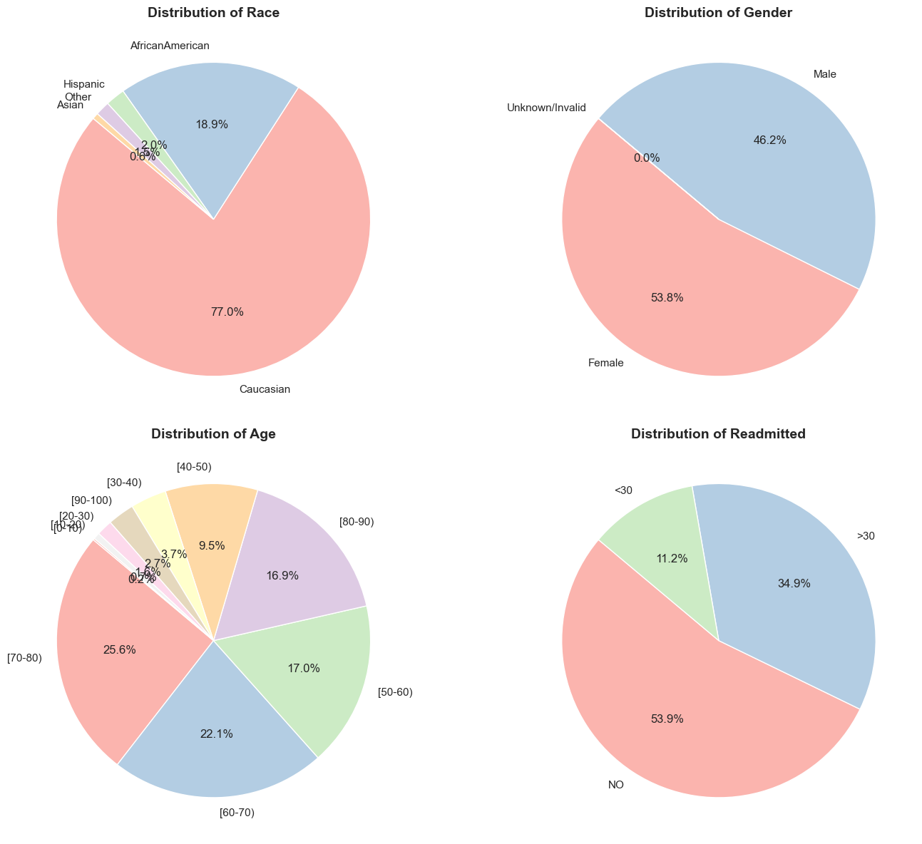

- Data Preprocessing & Feature Analysis
Figure 3: Missing Value Analysis
(Other columns 0 null values)
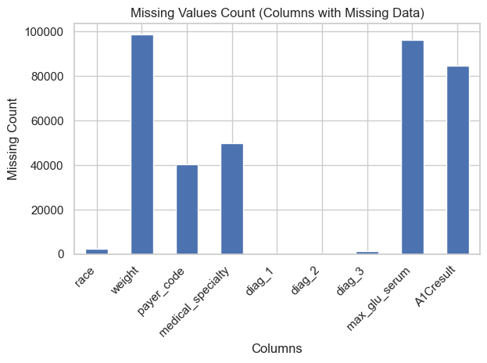
Type: Bar chart
Figure 4: Feature Correlation Heatmap
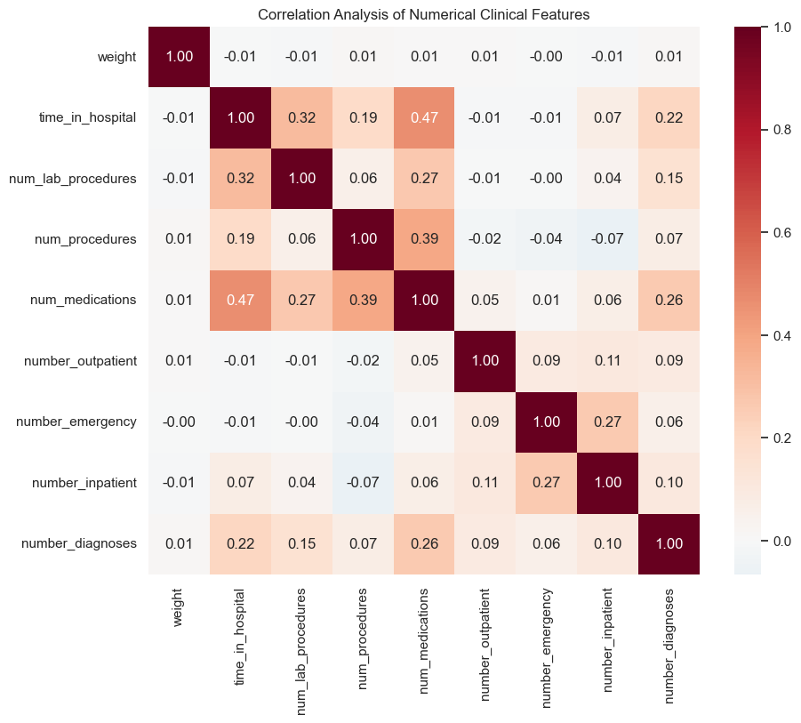

Figure 5: Feature Impacting readmission
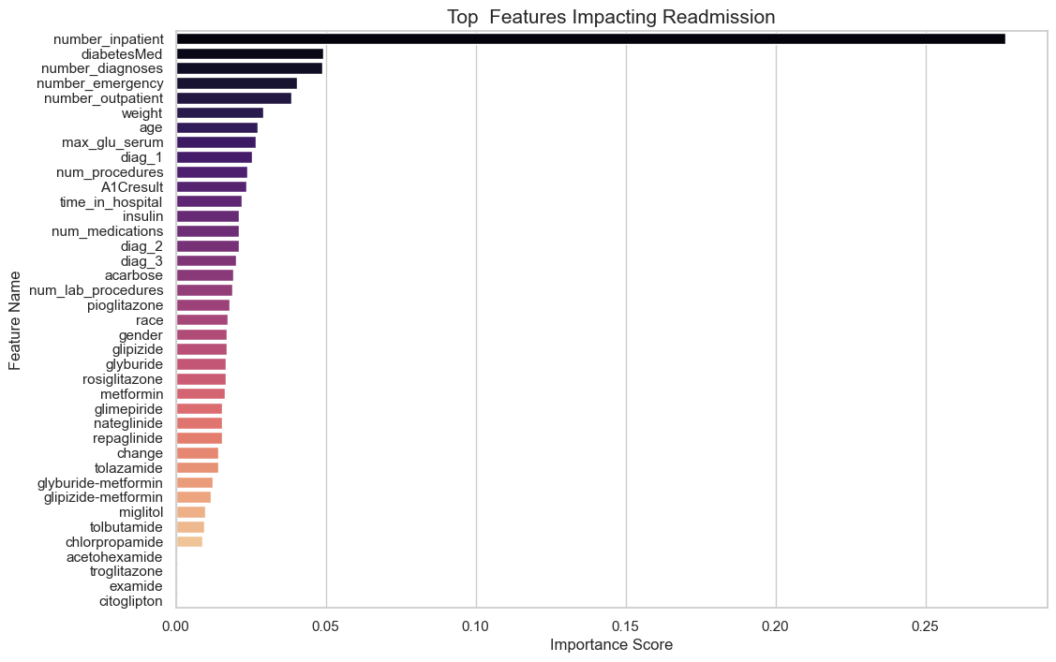
- Federated Learning Experimental Setup
Parameter | Value
Number of Clients | 3
Model Type | XGBoost
Aggregation Method | Federated Averaging
Number of Rounds | 2
Privacy Mechanism | Model-only sharing Weights

- Model Performance Evaluation (CORE SECTION)
Figure 6: Confusion Matrix – Local Models
Hospital-A
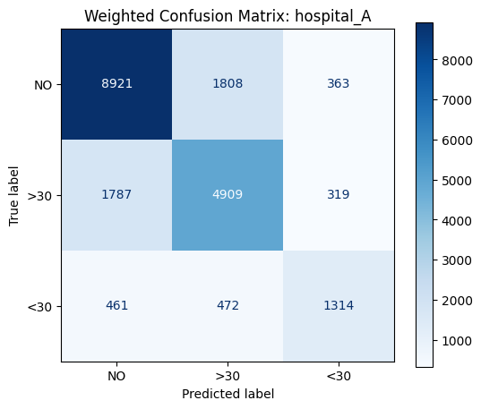
Hospital-B
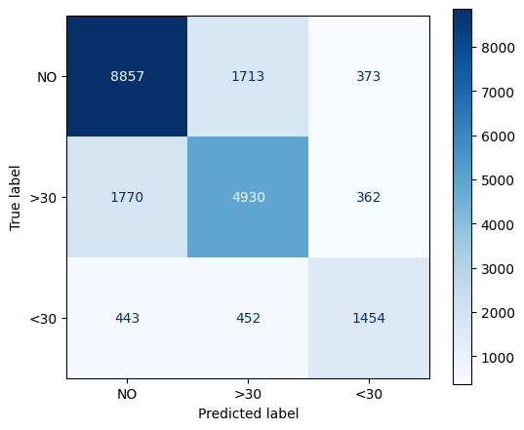
Hospital-C

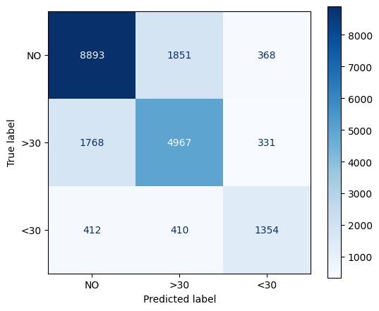
Figure 7: Confusion Matrix – Global Federated Model
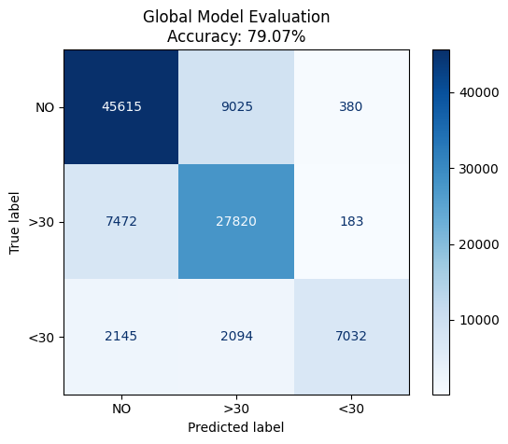

Figure 8: Accuracy Comparison Plot
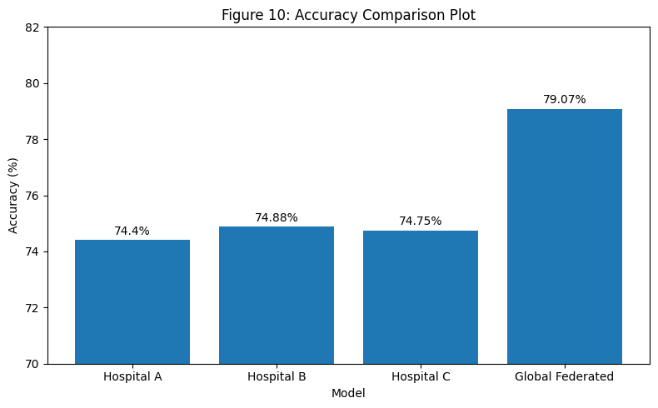

- Privacy & Security Analysis (VERY IMPORTANT FOR TITLE)

Table 2: Centralized vs Federated Learning Comparison
Aspect | Centralized | Federated
Data Sharing | Yes | No
Privacy Risk | High | Low
Regulatory Compliance | Difficult | Easy
Scalability | Limited | High

